CODE
++++++++++++++++++++++
import numpy as np
# Sample list of numbers
numbers = [10, 20, 30, 40, 50]
# Calculate standard deviation
std_dev = np.std(numbers, ddof=1)
# ddof=1 for sample standard deviation
print("Standard Deviation:", std_dev)

import numpy as np
# Sample list of numbers numbers = [10, 20, 30, 40, 50]
# Calculate mean
mean = np.mean(numbers)
print("Mean:", mean)

linear regation on array
import numpy as np
# Sample data: X (features) and y (target)
X = np.array([1, 2, 3, 4, 5]) # Feature array (1D array)
y = np.array([2, 4, 6, 8, 10]) # Target array (1D array)
# Add a column of ones to X for the intercept term
X = np.vstack([X, np.ones(len(X))]).T
# Perform linear regression coefficients, intercept = np.linalg.lstsq(X, y, rcond=None)[0]

# Output the results
print("Slope:", coefficients[0])
print("Intercept:", coefficients[1])

plt.subplots() = input is 1,2

Median Absolute Deviation
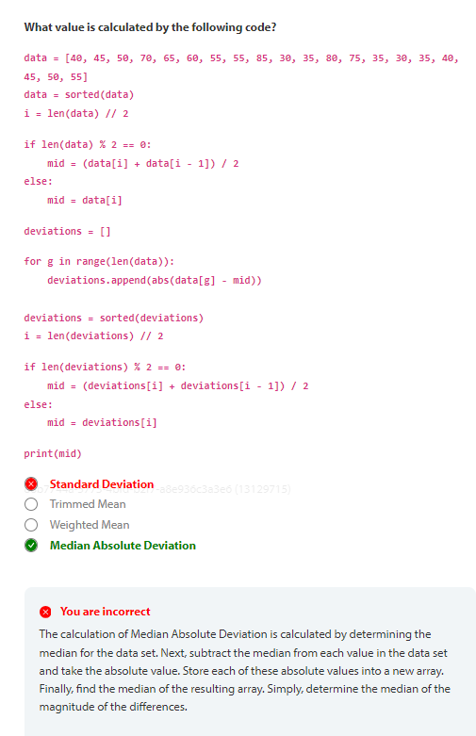
==========================================================================
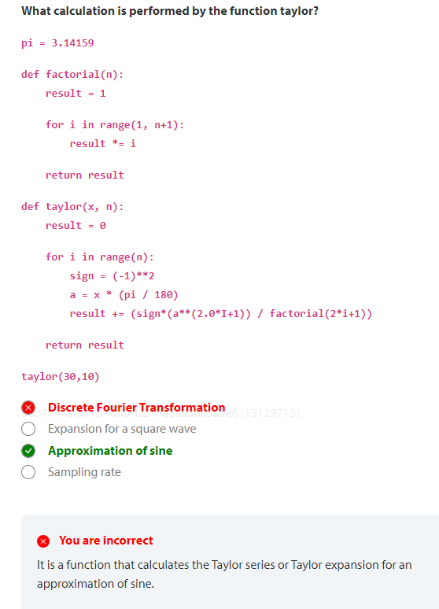

=============================================================================
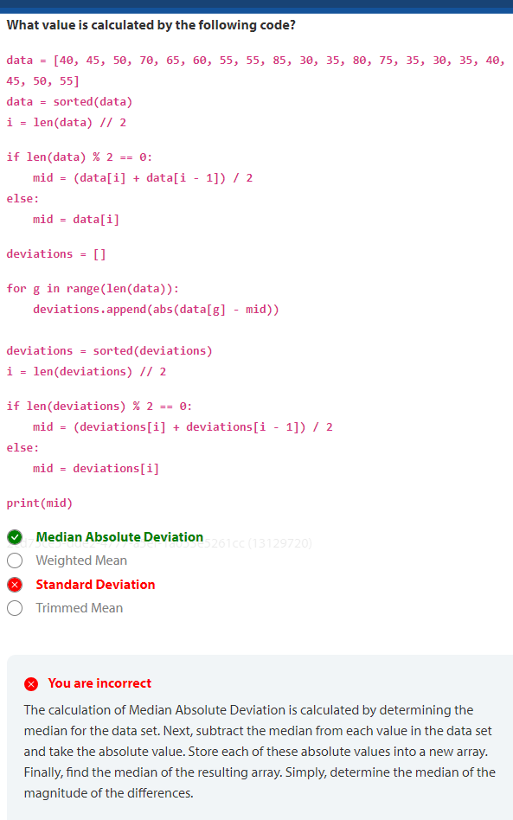
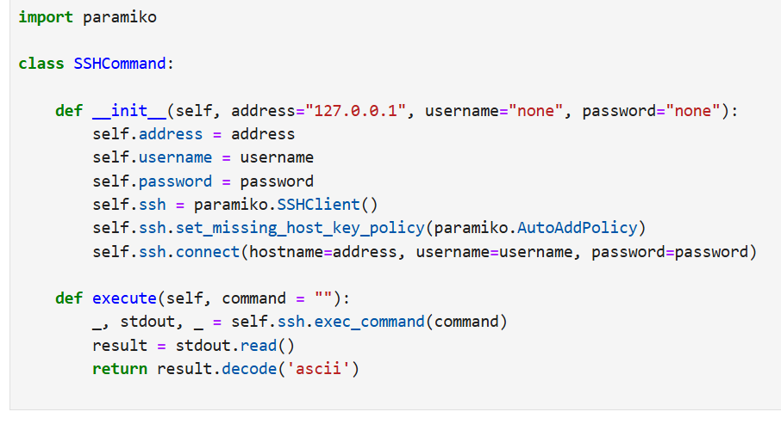rrect
The calculation of Median Absolute Deviation is calculated by determining the median for the data set. Next, subtract the median from each value in the data set and take the absolute value. Store each of these absolute values into a new array. Finally, find the median of the resulting array. Simply, determine the median of the magnitude of the differences.

++++++++++++++++++++++

Python Lab
what is the median of last column
24543.5
import numpy as np
data = np.genfromtxt("data/counts.tsv")
counts = data[:,1]
median = np.median(counts)
print(median)

Netflow
[9.02751976e+07 2.12457644e+10] To determine the coefficients that fit the flows for all except the last twelve values, use the following code sample:
bytes_fit = np.polyfit(range(0, stats.shape[0]-12), stats[:-12,1], deg=1)
print(bytes_fit)

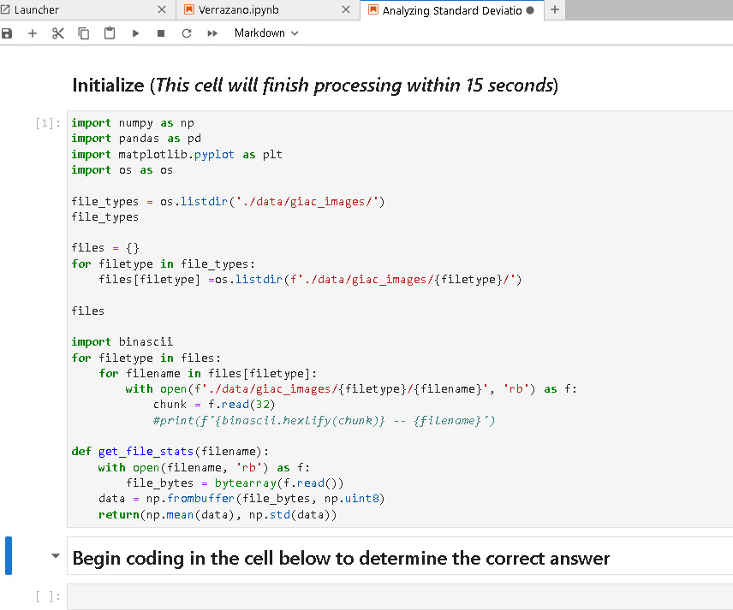

+++++++++++++++++++++++++++++++++++++++++++++++++++++++++++++++++++++++++++++

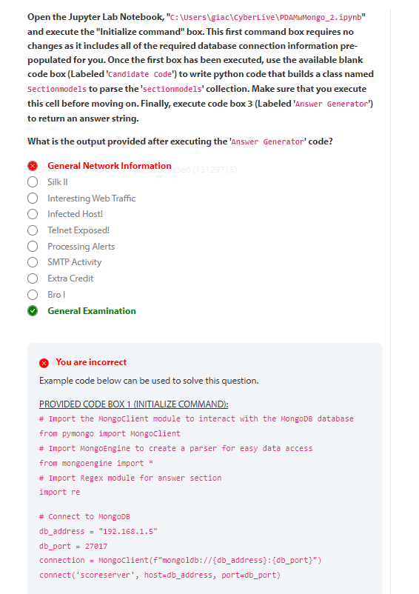You are incorrect
Example code below can be used to solve this question.
PROVIDED CODE BOX 1 (INITIALIZE COMMAND):
# Import the MongoClient module to interact with the MongoDB database
from pymongo import MongoClient
# Import MongoEngine to create a parser for easy data access
from mongoengine import *
# Import Regex module for answer section
import re
# Connect to MongoDB
db_address = "192.168.1.5"
db_port = 27017
connection = MongoClient(f"mongoldb://{db_address}:{db_port}")
connect('scoreserver', host=db_address, port=db_port)
# Connect to the Scoreserver database
db = connection.scoreserver
BLANK BOX SOLUTION (CANDIDATE CODE):
# Show an example entry for 'sectionmodels' to identify field names
db['sectionmodels'].find_one()
# Define a class named Sectionmodels
class Sectionmodels(Document):
index = IntField()
value = IntField()
description = StringField()
name = StringField()
questions = ListField(StringField())
question = StringField()
v = IntField(db_field='__v')
PROVIDED CODE BOX 3 (ANSWER GENERATOR):
# Once your class has been created, execute the box. Your answer will be shown.
GIAC_Candidate_Class = Sectionmodels
for number in range(65):
try:
answer = re.findall('Zeek', Sectionmodels.objects()[number].description)
If len(answer) > 1:
print(f'The answer is:\n')
print(Sectionmodels.objects()[number].name)
else:
continue
except:
print(f'Please double check that your class name is "Sectionmodels" and try again.')
break
The output of the code above, if the class is written correctly will display the name of the section that includes the word "Zeek" more than once in the description field. It is presented to the candidate simply as "the answer" in the output and will be "General Examination". The only code required to be written by the candidate is the Class definition statement.

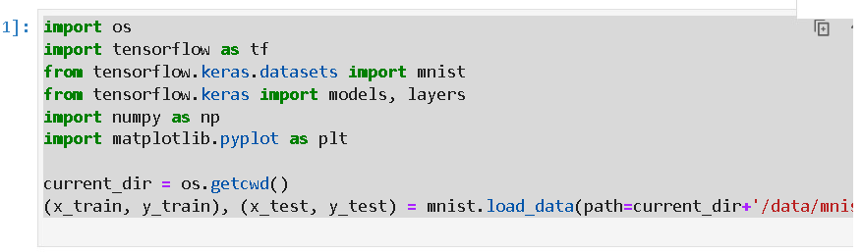

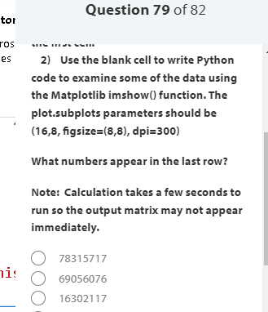

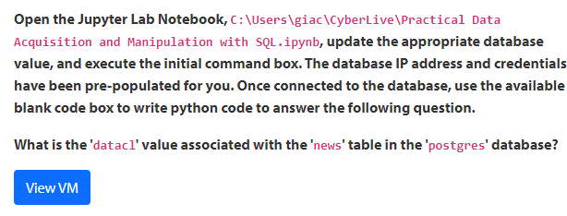

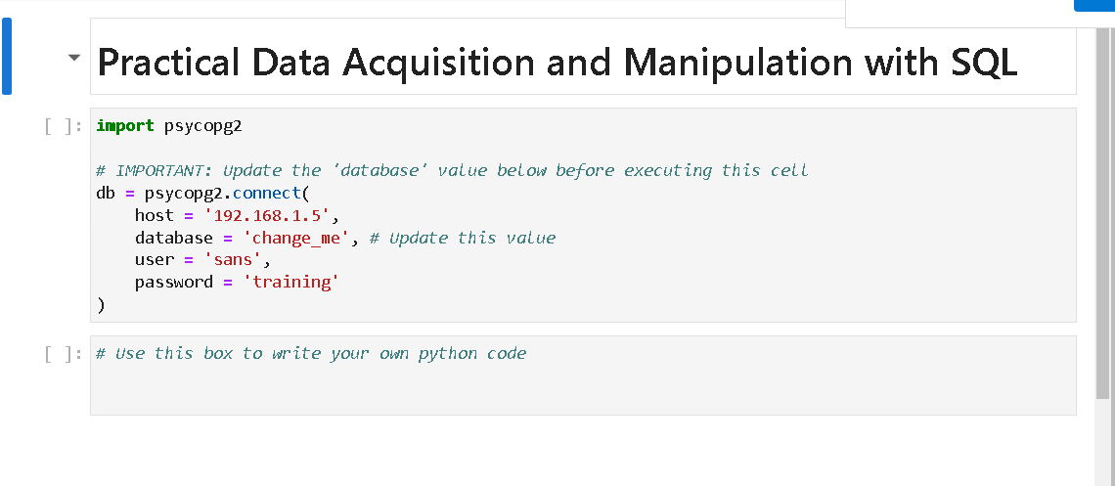

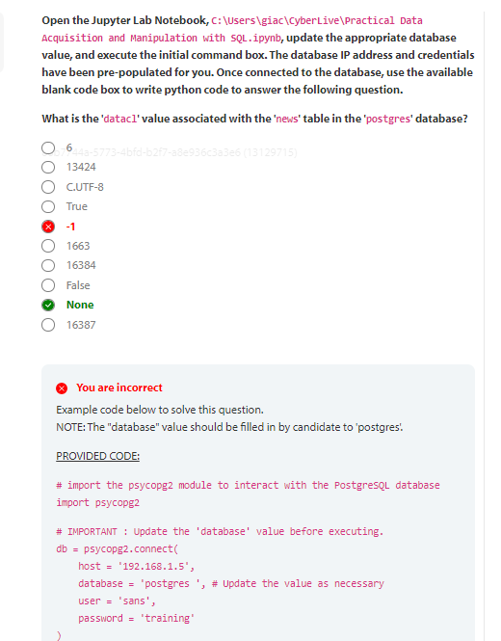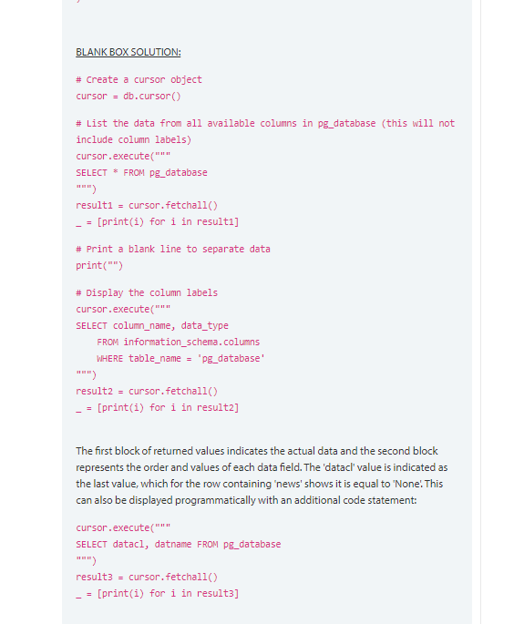

88b7744a-5773-4bfd-b2f7-a8e936c3a3e6 (13129715)
6
13424
C.UTF-8
True
-1
1663
16384
False
None
16387
You are incorrect
Example code below to solve this question.
NOTE: The "database" value should be filled in by candidate to 'postgres'.
PROVIDED CODE:
# import the psycopg2 module to interact with the PostgreSQL database
import psycopg2
# IMPORTANT : Update the 'database' value before executing.
db = psycopg2.connect(
host = '192.168.1.5',
database = 'postgres ', # Update the value as necessary
user = 'sans',
password = 'training'
)

BLANK BOX SOLUTION:
# Create a cursor object
cursor = db.cursor()
# List the data from all available columns in pg_database (this will not include column labels)
cursor.execute("""
SELECT * FROM pg_database
""")
result1 = cursor.fetchall()
_ = [print(i) for i in result1]
# Print a blank line to separate data
print("")
# Display the column labels
cursor.execute("""
SELECT column_name, data_type
FROM information_schema.columns
WHERE table_name = 'pg_database'
""")
result2 = cursor.fetchall()
_ = [print(i) for i in result2]
The first block of returned values indicates the actual data and the second block represents the order and values of each data field. The 'datacl' value is indicated as the last value, which for the row containing 'news' shows it is equal to 'None'. This can also be displayed programmatically with an additional code statement:
cursor.execute("""
SELECT datacl, datname FROM pg_database
""")
result3 = cursor.fetchall()
_ = [print(i) for i in result3]

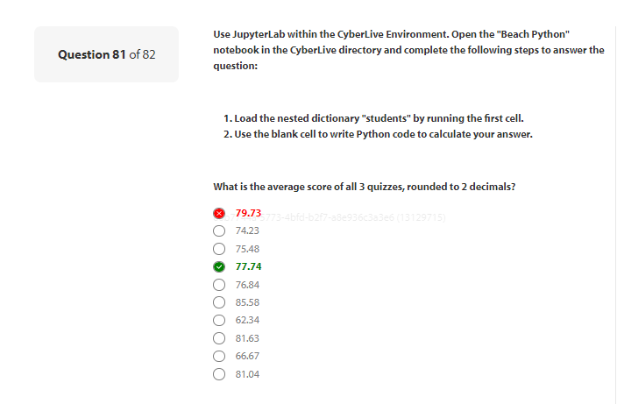

You are incorrect
Here are a couple of solutions:
Solution 1:
quiz_roll = []
flatlist = []
total = 0
i=0
avg = 0.0
for key, subdict in students.items():
for k, v in subdict.items():
if k == 'Quiz1' or k == 'Quiz2' or k == 'Quiz3':
temp = students[key][k]
quiz_roll.append(temp)
i += 1
flatlist=[element for sublist in quiz_roll for element in sublist]
total = sum(flatlist)
avg = round(total / i, 2)
print(total,i,avg)
Solution 2
tab = 0
i=0
avg = 0.0
for key, subdict in students.items():
for k, v in subdict.items():
if k == 'Quiz1' or k == 'Quiz2' or k == 'Quiz3':
temp = students[key][k]
tab += int(temp[0])
i += 1
avg = round(tab/ i, 2)
print(tab,i,avg)

